| Toure_Ousmane & Jianning Chen  EECE2160 | Embedded Design: Enabling Robotics  Lab Assignment 4 |
| --- | --- |

Lab Assignment 4

Lab Report Template and Guide

Ousmane Toure & Jianning Chen

Toure.o@northeastern.edu

Submit date: 6/2/2022

Due Date: 6/3/2022

**4.3 Section 3 of Lab 4**

#include <iostream>

#include <string>

int main(){

int array[8];

int input;

int count = 0;

while(count < 8){

std::cout << "Enter a number for bit [" << count << "]: ";

std::cin >> input;

if(!(input == 0 || input == 1)){

std::cout << "Please enter either 0 or 1" << std::endl;

}

else{

array[count] = input;

count ++;

}

}

int decimal = 0;

std::string hex;

for(int i = 0; i < 8; i++){

if(i == 0){decimal += array[i];}

else{

int temp = 1;

for(int j = 0; j < i; j++){temp = 2*temp*array[i];}

decimal += temp;

}

}

std::cout << "Decimal: " << decimal << std::endl;

int temp = decimal;

int remainder;

char temp_string;

while(temp != 0){

remainder = temp%16;

if(remainder < 10){temp_string = '0' + remainder;}

else if(remainder == 10){temp_string = 'A';}

else if(remainder == 11){temp_string = 'B';}

else if(remainder == 12){temp_string = 'C';}

else if(remainder == 13){temp_string = 'D';}

else if(remainder == 14){temp_string = 'E';}

else{temp_string = 'F';}

hex.insert(hex.begin(),temp_string);

temp = temp/16;

}

std::cout << "Hexadecimal: " << hex << std::endl;

return 0;

}

For section 3 of the lab, the algorithm is: converting the binary number to decimal number first, and then convert the decimal number into hexadecimal number. Since converting the binary number into decimal number is just adding all elements in the array with 2 to the power of the slot they are stored times the number itself. Therefore, the decimal number can be stored in an integer variable. For the hexadecimal number, it can be calculated by calculating the remainder of the number divided by 16, if the modulo is bigger than 9, then convert that bit with the letter it is corresponding to. This is done through a while loop, first copy the decimal number and store it in another variable named temp, when calculating the modulo, keep dividing the temp by 16. The stopping condition is when temp is equal to 0.

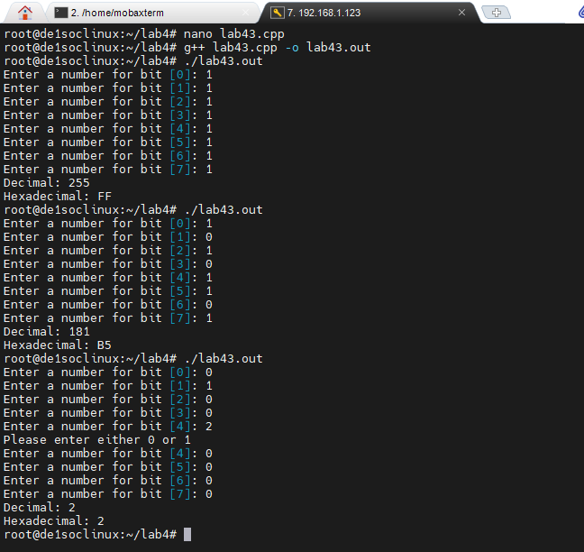

**4.4 Section 4 of Lab 4**

#include <iostream>

using namespace std;

int main()

{

char arr[33] = {0}; // initializing array size 33

int user; // user value to be inputted

cout << "Please enter an unsigned decimal number:";

cin >> user;

int size = 32;

for (int temp = user; temp; temp >>= 1) //size counter

size--;

for (int i = 0; i < size; ++i) //iterates through array,

arr[i] = ((user >> (size - i - 1)) & 1) ? '1' : '0'; //compares if a point in the array has a remainder or not.

cout << arr << endl;

return 0;

}

4.4 is a rather simple code, it declares an array of size 33 filled with zeros. The code works by iterating through the user inputted number and comparing its remainder to decide if it should have a 1 or 0, where a zero would mean there is no remainder. The for loop iterates through this 32 times.

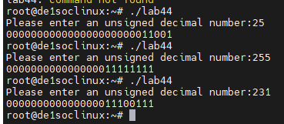

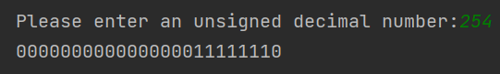

**4.5 Section 5 of Lab 4**

#include <iostream>

#include <string>

int main(){

int array[8];

int input;

int count = 0;

int condition;

bool goodjob = true;

std::cout << "Welcome to Lab 4, my name is Alan and I would like"

" you to select one of the options below: " << std::endl;

while(goodjob){

std::cout << "\"1\" to Convert an unsigned binary number to Decimal"

" and Hexadecimal." << std::endl;

std::cout << "\"2\" to display a 32-bit number representation of an unsigned Decimal number." << std::endl;

std::cout << "\"3\" to exit the main menu which ends the program."

<< std::endl;

std::cout << "Your input: ";

std::cin >> condition;

switch(condition){

case 1:{

while(count < 8){

std::cout << "Enter a number for bit [" << count << "]: ";

std::cin >> input;

if(!(input == 0 || input == 1)){std::cout << "Please enter either 0 or 1" << std::endl;}

else{

array[count] = input;

count ++;

}

}

int decimal = 0;

std::string hex;

for(int i = 0; i < 8; i++){

if(i == 0){decimal += array[i];}

else{

int temp = 1;

for(int j = 0; j < i; j++){temp = 2*temp*array[i];}

decimal += temp;

}

}

std::cout << "Decimal: " << decimal << std::endl;

int temp = decimal;

int remainder;

char temp_string;

while(temp != 0){

remainder = temp%16;

if(remainder < 10){temp_string = '0' + remainder;}

else if(remainder == 10){temp_string = 'A';}

else if(remainder == 11){temp_string = 'B';}

else if(remainder == 12){temp_string = 'C';}

else if(remainder == 13){temp_string = 'D';}

else if(remainder == 14){temp_string = 'E';}

else{temp_string = 'F';}

hex.insert(hex.begin(),temp_string);

temp = temp/16;

}

std::cout << "Hexadecimal: " << hex << std::endl;

std::cout << std::endl;

count = 0;}

break;

case 2:{

std::cout << "Please enter a decimal number: ";

std::cin >> input;

std::string output;

int remainder;

char rem;

while(input != 0){

remainder = input%2;

rem = '0' + remainder;

output.insert(output.begin(),rem);

input = input/2;

}

if(output.size() < 32){while(output.size() < 32){output.insert(output.begin(),'0');}}

else if(output.size() > 32){

int diff = output.size() - 32;

output.erase(0,diff);

}

std::cout << "Your 32-bit number is: " << output << std::endl;

std::cout << std::endl;}

break;

case 3:

std::cout << "Goodbye!" << std::endl;

std::cout << std::endl;

goodjob = false;

break;

default:

std::cout << "Your command cannot be recognized"

", please enter another key: " << std::endl;;

}

}

return 0;

}

4.5 is a combination of 4.3 and 4.4. The thing added is a user input that changes mode. This is done by using the switch command inside a while loop. Each time in the loop, the system will ask for a user input and then perform operations based on the user input. 3 will be the only option to quit the loop. If the user input a number different from 1, 2 and 3, the system will throw the user an error and ask for input again.

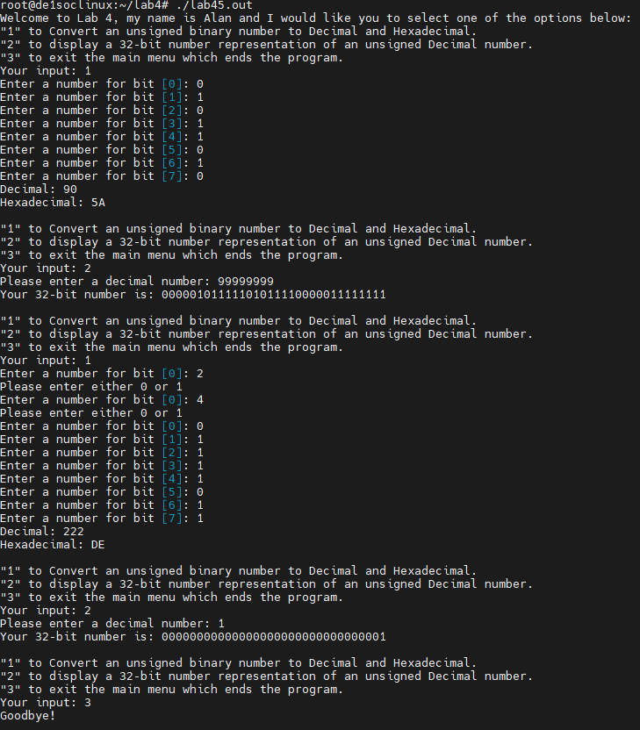

**4.6 Section 6 of Lab 4**

#include <iostream>

#include <string>

using namespace std;

void PrintArray (int v[], int size)

{

cout<<"your "<<size<<"bit number is: ";

for(int i=0;i<size;i++)

cout<< v[i]<<"";

cout<<endl;

}

void PrintArrayAddress (int v[], int size) {

for (int i = 0; i < size; i++) {

cout << "Address of slot " << i << ": " << &v[i] << endl;

}

}

int main(){

int array[8];

int input;

int count = 0;

int condition;

bool goodjob = true;

std::cout << "Welcome to Lab 4, Please select one of the options below: " << std::endl;

while(goodjob){

std::cout << "\"1\" to Convert an unsigned binary number to Decimal"

" and Hexadecimal." << std::endl;

std::cout << "\"2\" to display a 32-bit number representation of an unsigned"

" Decimal number." << std::endl;

std::cout << "\"3\" to exit the main menu which ends the program."

<< std::endl;

std::cout << "Your input: ";

std::cin >> condition;

switch(condition){

case 1:{

while(count < 8){

std::cout << "Enter a number for bit [" << count << "]: ";

std::cin >> input;

if(!(input == 0 || input == 1)){std::cout << "Please enter either 0 or 1" << std::endl;}

else{

array[count] = input;

count ++;

}

}

int decimal = 0;

std::string hex;

for(int i = 0; i < 8; i++){

if(i == 0){decimal += array[i];}

else{

int temp = 1;

for(int j = 0; j < i; j++){temp = 2*temp*array[i];}

decimal += temp;

}

}

std::cout << "Decimal: " << decimal << std::endl;

PrintArray(array,8);

int temp = decimal;

int remainder;

char temp_string;

while(temp != 0){

remainder = temp%16;

if(remainder < 10){temp_string = '0' + remainder;}

else if(remainder == 10){temp_string = 'A';}

else if(remainder == 11){temp_string = 'B';}

else if(remainder == 12){temp_string = 'C';}

else if(remainder == 13){temp_string = 'D';}

else if(remainder == 14){temp_string = 'E';}

else{temp_string = 'F';}

hex.insert(hex.begin(),temp_string);

temp = temp/16;

}

std::cout << "Hexadecimal: " << hex << std::endl;

std::cout << std::endl;

count = 0;

PrintArrayAddress(array,8);

}

break;

case 2:{

std::cout << "Please enter a decimal number: ";

std::cin >> input;

std::string output;

int remainder;

char rem;

int bin_arr[32] = {0};

int c = 32;

while(input != 0){

remainder = input%2;

bin_arr[c] = remainder;

c--;

input = input/2;

}

PrintArray(bin_arr,32 );

PrintArrayAddress(bin_arr,32);

std::cout << std::endl;

}

break;

case 3:

std::cout << "Goodbye!" << std::endl;

std::cout << std::endl;

goodjob = false;

break;

default:

std::cout << "Your command cannot be recognized"

", try again: " << std::endl;;

}

}

return 0;

}

4.6 built on 4.5’s work. By removing the print functions in each case statement, we could define functions PrintArray and PrintArrayAddress. Both functions were created so that instead of manually typing the results and controlling the sizes of the array, any sized array can be used now and the print statements reflect that.

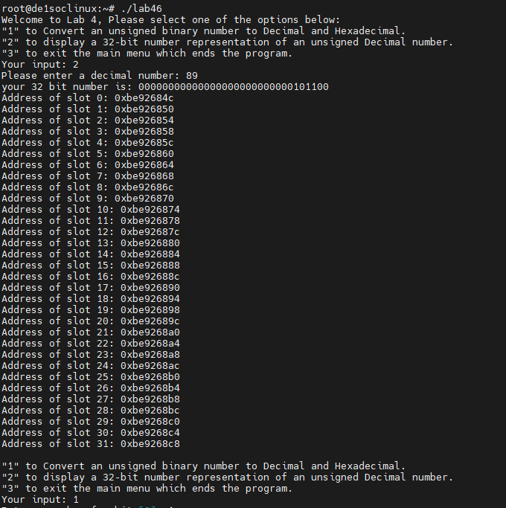

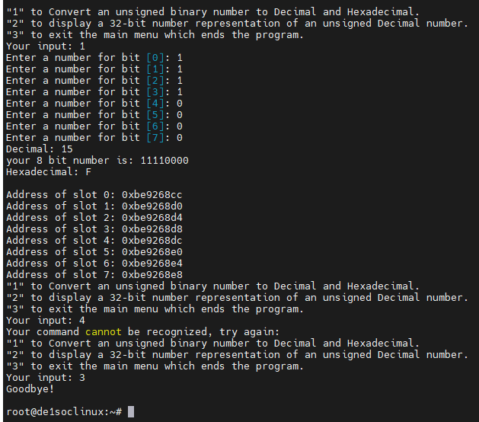

# References

1. Prof. Julius Marpaung, “*Lab Report Guide*”, Northeastern University, January 6 2020.